Title of the Paper, Capitalize First Letter of Nouns, Pronouns, Adjectives, Verbs, Adverbs, and Subordinating Conjunctions
First Author ª, Second Author ^{b}, Third Author ^{c}
ª First affiliation, Address, City and Postcode, Country
http://yourorganization.web.page
^{b} Second affiliation, Address, City and Postcode, Country
http://yourorganization2.web.page
^{c} Third affiliation, Address, City and Postcode, Country
http://yourorganization2.web.page
ABSTRACT
Brief description of the study objectives, observations/ experiments performed, resulting data, findings, intended use.
Do not include mathematical formulas, footnote marks, and numbered references in the abstract.
Length – between 100 and 200 words.
End of abstract.

ARTICLE INFO  Received: 09 Oct 20xx  Revised: 10 Nov 20xx  Accepted: 30 Nov 20xx  Online: 12 Dec 20xx | KEYWORDS  4-8 comma separated Index Terms, in alphabetical order; Acronyms can be included if they are defined in the paper.  Creative Commons BY-NC-SA 4.0

I. Overview
The Journal of Defence & Security Technologies (J. Def & Sec Technol.; JDST) is an open-access peer-reviewed publication. Each accepted paper appears online as soon as it is ready, and is immediately citable and accessible free of any charges to interested readers and without requiring registration of any sort.
JDST publishes papers in English or in Bulgarian. Contributions in the Bulgarian language include an extended abstract in English.
The JDST Editorial Board requests that all papers, accepted for publication, are submitted by their authors prepared using this template and adhering to the following guidelines. A failure to prepare the paper accordingly will significantly delay its online publication and may, on the consideration of the Editorial Board, be rejected.

A. Enumeration of Headings, if Used
Section headings of up to three levels may be used: primary; secondary; and tertiary heads. The author decides to use enumeration or not. The choice must be consistent throughout the paper. Reference and Acknowledgment headings shall not be enumerated.
Primary headings are enumerated by Roman numerals and centred above the text. Small caps and capitalised terms shall be used in primary headings.
Below you can find guidance and examples of other headings.

B. This is a Secondary Heading
Secondary headings are enumerated by capital letters, flush left, upper and lower case, and italic.
1) This is a tertiary heading: Tertiary headings are enumerated by Arabic numerals followed by parentheses. They run into the text in their sections, italic, upper and lower case, and followed by a colon.
2) Reference and Acknowledgment: Reference and Acknowledgment headings are unlike all other section headings in text. They are never enumerated. They are simply primary headings without labels, regardless of whether the other headings in the papers are enumerated.
3) Appendixes: Appendix headings are a special case. The primary heading(s) in the Appendix or Appendixes (note spelling of plural) are set according to the usual style, except that there is flexibility in the enumeration of the heading. The author may use Roman numerals as heading numbers (Appendix I) or letters (Appendix A). The Appendix heading is not preceded by a Roman numeral. If there is only one Appendix in the paper, the Appendix heading is unnumbered and unnamed.

C. Guidance on the Introductory Section
Outline the motivation for the study. Describe the study design, the data generated, any background information needed to put the study in the context of previous work and the literature.
Reference literature sources as needed (see also the section on the reference style below).
Outline the content of the paper.

II. Second Section
For example, this section may provide a detailed description on the methods and procedures used in the study.
When data is presented, authors are required to anonymize any personal data that may be contained in presented data.

III. Language, Spelling and Format

A. Spelling and Bullets
Authors from the United States are welcome to use U.S. spelling. All other authors, please use consistently U.K. spelling. For referenced sources, use the title as given in the original publication.
Bulleted and numbered lists may be included and should look like this:
- First point
- Second point
- And so on
- Last bullet point.
Please do not alter the formatting and style layouts which have been set up in this template document.
Page numbers will be added by the publisher prior to the online publication.

B. Tables
All tables should be numbered with Arabic numerals. Every table should have a caption, placed above the table, left justified. Only horizontal lines should be used within a table, to distinguish the column headings from the body of the table, and immediately above and below the table. Tables must be embedded into the text and not supplied separately. Below is an example which the authors may find useful.
Please make sure that the table is not split between pages. Try to position each table at the top or the bottom of the page. If necessary, split the text para-
Table 1. An example of a table.
An example of a column heading | Column A  (t) | Column B  (h) | Column C (m) | Column D (deg) | Column E  (t) | Column F  (g)
An entry | 1 | 2
And another entry | 3 | 4
And another entry | 5 | 6
graph to allow proper positioning of a table. This final arrangement shall be performed by the authors after the text is hyphenated.

C. Charts, figures, photos
All figures should be numbered with Arabic numerals (1, 2, 3,….). Every figure should have a caption, located below the figure. All photographs, schemas, graphs and diagrams are to be referred to as figures. Line drawings should be good quality scans or true electronic output. Low-quality scans are not acceptable.
Figures must be embedded into the text and not supplied separately. In MS word input the figures must be properly coded. Lettering and symbols should be clearly defined either in the caption or in a legend provided as part of the figure. Figures should be placed at the top or bottom of a page wherever possible, as close as possible to the first reference to them in the paper.
The figure number and caption should be typed below the illustration in 10 pts and left justified.

D. Formulas
Equations are numbered consecutively from the beginning of the paper to the end. Numbering by section, e.g., (1.1), (1.2.1), (A1), is permitted.

E. Footnotes
Footnotes can be used sparingly. They are numbered separately in superscripts. Do not put footnotes in the reference list.

IV. Construction of References

A. Referencing in the Text
Citations in the text shall be numbered consecutively in square brackets [1]. Punctuation follows the bracket [2]. Refer simply to the reference number, as in
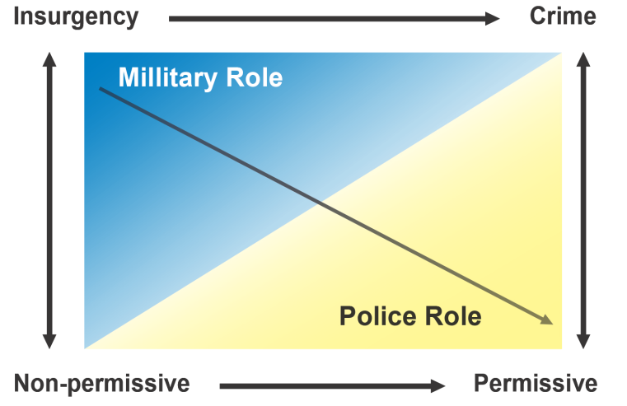
Figure 1: Sample illustration.
[3]. Use “Ref. [3]” or “Reference [3]” at the beginning of a sentence: “Reference [3] was the first ....” Grammatically, they may be treated:
- as if they were footnote numbers, e.g., as shown by Johnson [4], [5]; as mentioned earlier [2], [4]–[7], [9]; Woodward [4] and Brown and Jones [5]; Wood et al. [7] (Note: Use et al. when three or more names are given.); or
- as nouns, e.g. as demonstrated in [3]; according to [4] and [6]–[9].

B. Creating List of References
JDST adheres to the IEEE Citation Reference guide. The JDST refers interested contributors to https://www.ieee.org/documents/ieeecitationref.pdf. Some short guidelines are provided below.
For each referenced source, give all authors’ names; use “et al.” if there are six authors or more. Papers that have not been published, even if they have been submitted for publication, should be cited as “unpublished” [10]. Papers that have been accepted for publication should be cited as “in press” [11]. In a paper title, capitalize the first word and all other words except for conjunctions, prepositions less than seven letters, and prepositional phrases.
For papers published in translated journals, first give the English citation, then the original foreign-language citation [6].
Most referenced sources will have a DOI number assigned. It shall be included at the end of the referenced source, e.g. https://doi.org/10.11610/isij.2902. If a DOI is not available for an online source, include the most recent working URL of the source.

C. Basic Format
The basic format is as follows:
[1] C.J. Author, “Name of paper,” Abbrev. Title of Periodical, vol. x, no. y, pp. zzz-vvv, Abbrev. Month, year.
For the main types of sources see the examples in the References section below. Refer to https://www.ieee.org/documents/ieeecitationref.pdf for a detailed guidance.

V. Licenses
Authors who publish with JDST will retain all intellectual property rights, including moral rights in their work. Research, policy and other papers published in JDST, including the abstract, will be licensed to the public under “Creative Commons 4.0 Attribution-NonCommercial-ShareAlike” International license (CC BY-NC-SA 4.0).

VI. Conclusions
Once ready with the text, please hyphenate it using the feature incorporated in Word for Windows. Select ‘Manual’ hyphenation and do not hyphenate titles, URL addresses and the like. Avoid also hyphenation at the end of a line.
Once a paper is accepted and ready for online publication, the publisher will include it in the respective volume and issue of JDST, will insert page numbers and assign a DOI to it.

Acknowledgements
Acknowledgements and Reference heading should be centred, bold, with the first letter capitalized but have no numbers. Text below continues as normal.

References
[1] L. Urciuoli, T. Männistö, J. Hintsa, and T. Khan, “Supply Chain Cyber Security – Potential Threats,” Information & Security Int J, vol. 29, pp. 51-68, 2013. https://doi.org/10.11610/isij.2904.
[2] F. Siegle, T. Vladimirova, J. Ilstad and O. Emam, “Availability analysis for satellite data processing systems based on SRAM FPGAs,” IEEE Trans. Aerosp. Electron. Syst., vol. 52, no. 3, pp. 977-989, June 2016. https://doi.org/ 10.1109/TAES.2016.140914.
[3] S. Costigan and G. Lindström, “Policy and the Internet of Things,” Connections QJ, vol. 15, no. 2, pp. 9-18, Spring 2016. https://doi.org/10.11610/ Connections.15.2.01.
[4] M. Young, The Technical Writer's Handbook. Mill Valley, CA: University Science, 1989.
[5] J.K. Wither and S. Mullins, Eds., Combating Transnational Terrorism. Sofia: Procon, 2016. https://doi.org/10.11610/ctt.book.
[6] J. K. Author, “Title of paper,” in Unabbreviated Name of Conf., City of Conf., Abbrev. State (if given), year, pp. xxx-xxx.
[7] V. Georgiev, “A Two-Level Model for Describing the Risk Profile in Formulating Policy and Developing Security Capabilities,” Institute of ICT, Sofia, IT4Sec Reports 129, 2015.

Sara Hugelier, “Publishing Open-Access Biomedical Data: Legal Challenges,” Biomedical Data Journal 1, no. 1 (2015):43-51, http://dx.doi.org/10.11610/bmdj.01108.
Hugelier, “Publishing Open-Access Biomedical Data: Legal Challenges,” 47.

